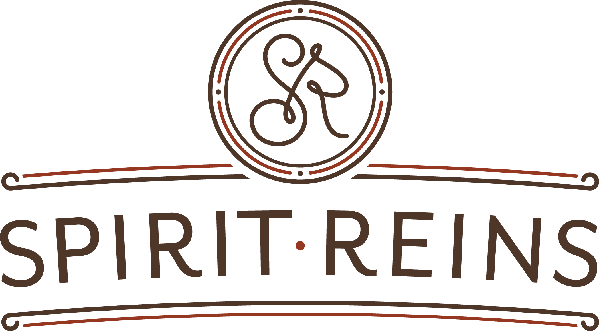

Financial Assistance Policy

As part of its commitment to serve the community and provide quality mental health services to all of our clients, Spirit Reins provides a Financial Assistance Policy to clients who satisfy certain requirements. As a non-profit organization, Spirit Reins has the ability to raise funds through grants, donations, and other resources to help clients in need with the cost of services.

Eligibility for Financial Assistance:
Based on your household income, you may qualify for partial financial assistance, on a sliding scale. To qualify for financial assistance, household income may not exceed 400% of the Federal Poverty Level as determined by the Federal Government at the beginning of each calendar year.

The granting of financial assistance shall be based on an individualized determination of financial need, and shall not take into account age, gender, race, social or immigrant status, sexual orientation, and gender identity or expression, or religious affiliation.

Financial Assistance Provided:
- Clients with income less than or equal to 100% of the Federal Poverty Level (“FPL”), will be eligible for a 85% adjustment on the cost of services. Clients with income between 101% FPL and 200% FPL will be eligible for a 80% adjustment on the cost of services.
- Clients with incomes above 200% of the FPL but not exceeding 400% of the FPL will receive a sliding scale discount on the cost of services:

Clients between 201% FPL and 250% FPL will receive a 75% adjustment

Clients between 251% FPL and 300% FPL will receive a 65% adjustment

Clients between 301% FPL and 350% FPL will receive a 50% adjustment

Clients between 351% FPL and 400% FPL will receive a 40% adjustment

Applying for Financial Assistance:
All clients who wish to receive financial assistance will be required to:
- Complete a Financial Assistance application. The Financial Assistance application and instructions are available on Spirit Reins’ website and/or will be made available upon client request at the time of service.
- Provide a copy of your most recent Federal Tax Return. The following supporting income verification documentation may be required:
- Three most recent Employer Pay Stubs
- IRS Form W-2
- Letter from employer on company letterhead verifying compensation
- Notification of Unemployment Benefits
- Proof of Social Security Income
- Once financial assistance is approved, assistance adjustments will be ongoing for up to six months. Clients will be reevaluated for financial assistance every six (6) months.

Appeal Process
The process for clients to appeal a decision regarding eligibility for financial assistance is as follows:
- Clients may submit a written appeal letter by mail or in person to the Finance Director. The appeal letter should include financial information not considered in the client’s original Financial Assistance Application, important to reconsidering the client’s eligibility for financial assistance. In addition to the written appeal letter, clients must include documentation of reconsideration information included in the appeal letter. Without appropriate documentation, the consideration of the appeal may be delayed until appropriate documentation is received. The appeal letter and supporting documentation must be delivered in person or mailed to: Finance Director at P.O. Box 368, Liberty Hill, TX 78642.
- All appeals will be considered by Spirit Reins Executive Director and Finance Director, and a decision will be sent in writing to the client who filed the appeal.

Attachment “A”
Discount Matrix

Patient/Guarantor Annual Income as a Percentage of the Federal Poverty  Level (FPL) | Adjustment Percentage | Cost per experience
Less than 100% of FPL | 85% | $9.00
101% to 200% of FPL | 80% | $12.00
201% to 250% of FPL | 75% | $15.00
251% to 300% of FPL | 65% | $21.00
301% to 350% of FPL | 50% | $30.00
351% to 400% of FPL | 40% | $36.00

Listed below are the 2020 100% Federal Poverty Guidelines:

Persons in Family/Household | Annual Income
1 | $ 12,760
2 | $ 17,240
3 | $ 21,720
4 | $ 26,200
5 | $ 30,680
6 | $ 35,160
7 | $ 39,640
8 | $ 44,120

Calculation:
Annual Household Income/Persons in Family Annual Income X 100 = Percentage of Federal Poverty Level
Example: Family of 3 with Annual Income of $42,750 and a charge of $60. 42,750/ 21,720 X 100 = 196.82 or 197% of FPL
In this example with a charge of $60, the patient/guarantor would owe 20% of $60 or
$12.

Attachment “B”

Spirit Reins Financial Assistance Program
Application for Financial Assistance
Patient Name:___________________________________________________________

Patient Guarantor Name:__________________________________________________
Address:_______________________________________________________________
_______________________________________________________________
_______________________________________________________________
Daytime Telephone:______________________________________________________

Yearly Household Income:________________________

Total Household Members:________________

