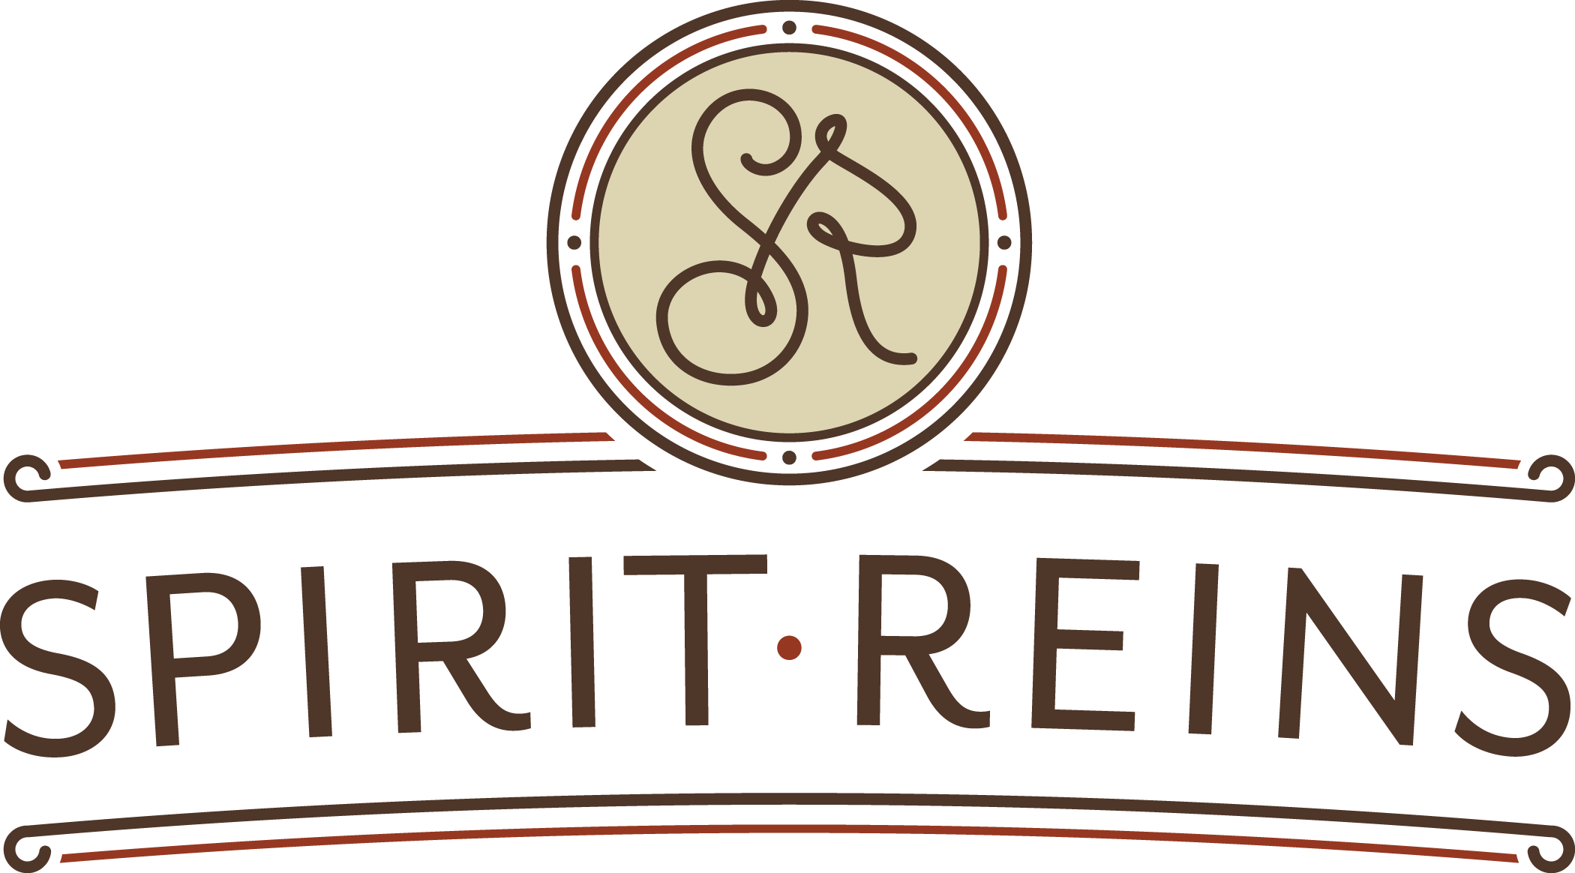
Spirit Reins Herd Member Toolkit: Giving Tuesday & Herd for the Holidays 2019

We sincerely appreciate your heart for Spirit Reins! Thank you so much for joining us as a Giving Tuesday and End of Year Herd Member.

The following social media content has been developed to help you, as a Spirit Reins Herd Member, bring awareness to our healing mission, share why your support us, and inspire your family and friends to make a gift and join the Herd for the Holidays!

Here, you’ll find ready-made content and visuals for you to post to your social media platforms. We know that audiences may vary, so please feel free to customize or add your own photos and videos of Spirit Reins! To download the visuals as a (.jpg) format for posting, click here.

Spirit Reins Social Media Platforms Social Media Handles
Facebook: https://www.facebook.com/SpiritReinsTX @SpiritReinsTX
Instagram: https://www.instagram.com/spiritreins/ @spiritreins
Twitter: https://twitter.com/spiritreins @SpiritReins
LinkedIn: https://www.linkedin.com/company/spirit-reins

Hashtags
#spiritreins
#givingtuesday
#mygivingstory
#herdfortheholidays
#healingintheherd
#hopeintheherd

Contact with Questions
Austin Painchaud | Development Director at austin@spiritreins.org or (979) 885-0104
Monica Trout | Grants & Communications Coordinator at monica@spiritreins.org or (512) 778-9449

Post: December 1-2
[post copy]
This December 3rd is a day dedicated to making a difference! On Giving Tuesday, I will be making a difference at Spirit Reins. Spirit Reins is an incredible nonprofit that partners therapists and horses to help heal children and families who have experienced trauma. Mark your calendars and join me in supporting Spirit Reins on Giving Tuesday!

https://www.spiritreins.org/give

[visual]
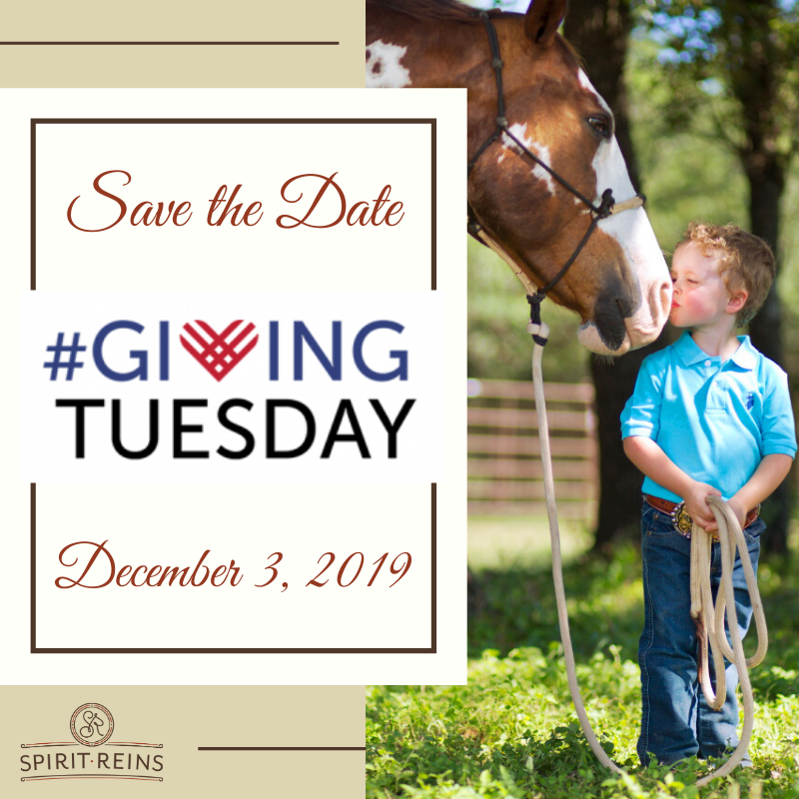

Post: December 3
[post copy]
Today’s the day! As a passionate believer in their mission of healing, I will be supporting Spirit Reins this #GivingTuesday. Spirit Reins is truly changing lives, and I am so glad to be part of the herd! Please consider joining the herd with me and making a gift to Spirit Reins today.

https://www.spiritreins.org/give

[visual]
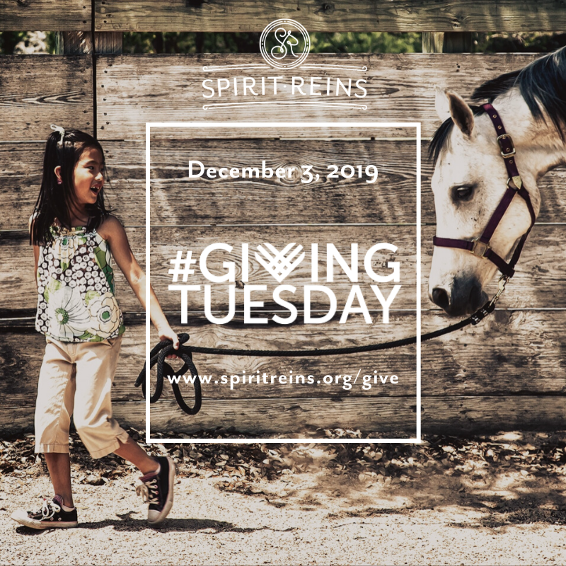

Post: December 3
[post copy]
Horses are such amazing partners in the work Spirit Reins does with children and families! As prey animals, horses live “in the moment”, and their partnership brings the power of the present and the power of their presence throughout a family’s healing journey. Join me in caring for the herd and the families they help by making a gift to Spirit Reins this #GivingTuesday!

https://www.spiritreins.org/give

[visual]
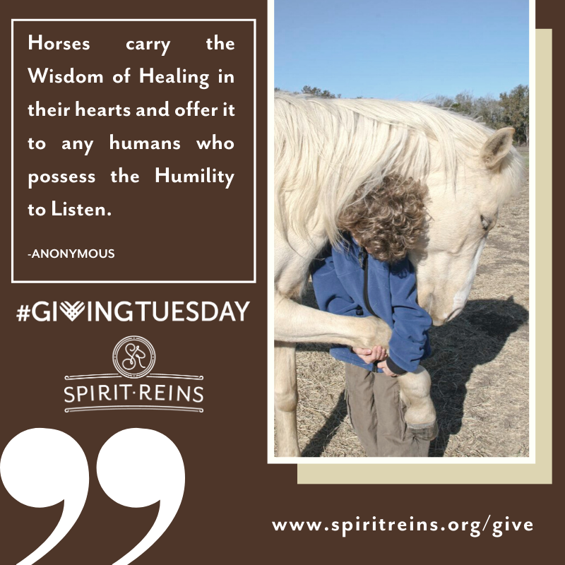 OR 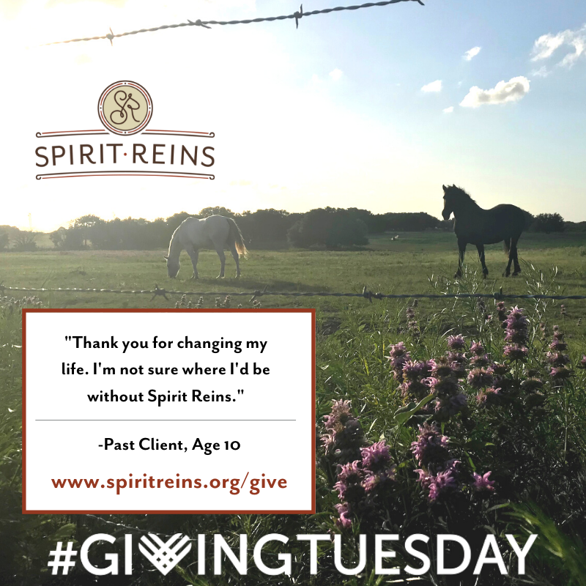

Post: December 3
[post copy]
Spirit Reins is providing children and families with the opportunity to heal from trauma, and I sincerely believe that by transforming families, we can transform our community. Will you join the herd?

https://www.spiritreins.org/give

[visual]
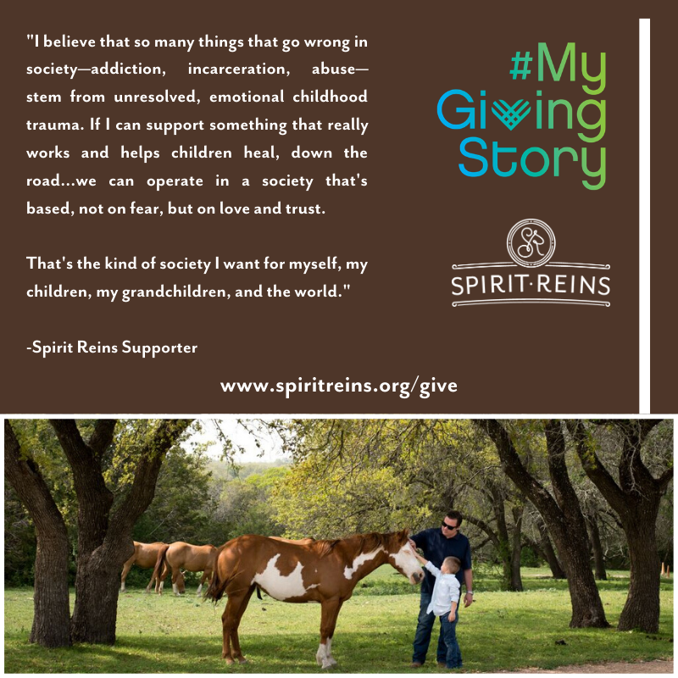

Post: December 3
[please customize this post copy]
**Note: Please tell your own giving story about why you support Spirit Reins!

https://www.spiritreins.org/give

[visual]
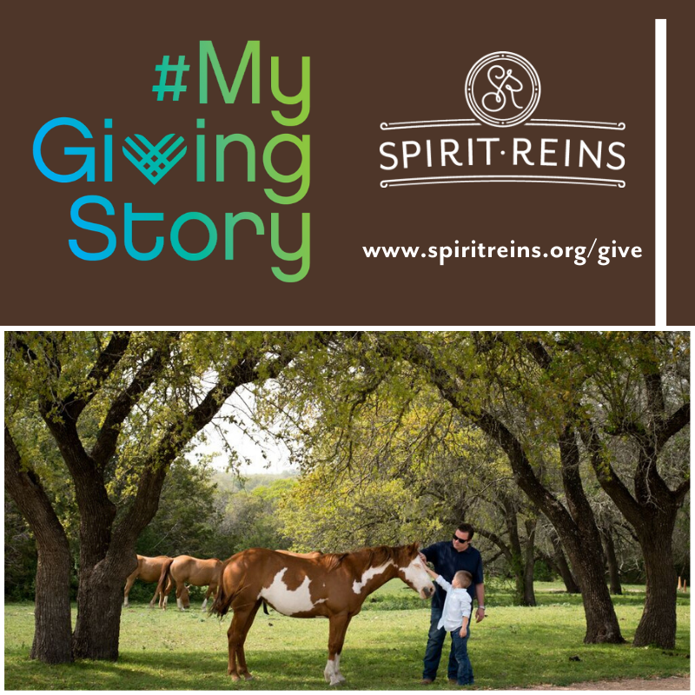

Post: December 5
[post copy]
Thank you to everyone who made a gift to Spirit Reins on #GivingTuesday! To anyone who still wants to support this wonderful nonprofit, it’s not too late. Give a gift, share your story, and join the Herd for the Holidays!

https://www.spiritreins.org/holidays

[visual]
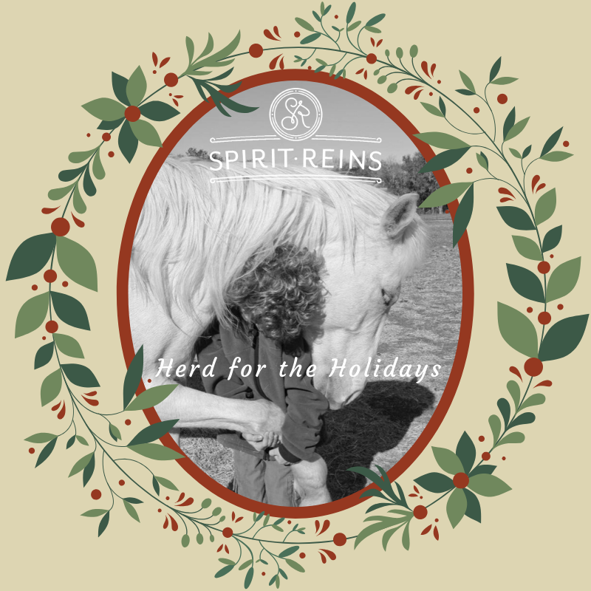

Post: December 12
[post copy]
Spirit Reins is a place where children experience safety and belonging; a place to be seen and feel heard; a place to heal and to hope. For children who don’t feel at home during the holidays, they come to Spirit Reins and know that a team is waiting to walk alongside them in their healing journeys. Make a gift to Spirit Reins and be part of a community that extends a sense of belonging to all who seek it.

https://www.spiritreins.org/holidays

[visual]
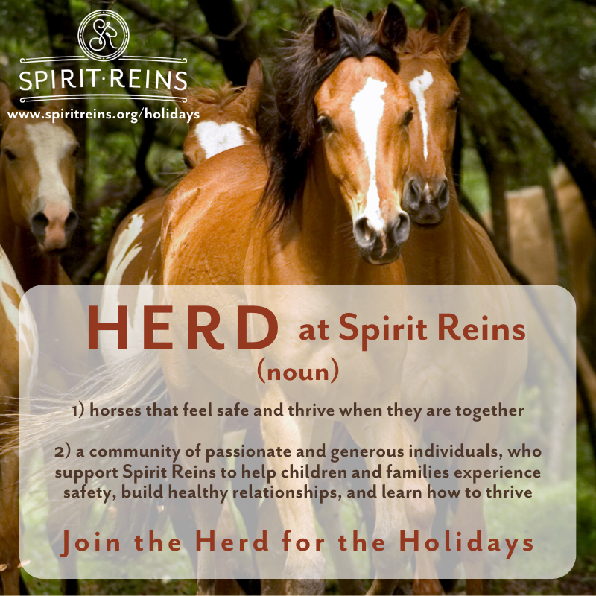

Post: December 17
[post copy]
For most, there is a joy in being home for the holidays. The holiday season is a time of cheer—full of twinkling lights, family, and glad tidings. It’s a time when you’re surrounded by the feeling of being safe and loved. However, for many of the children in services at Spirit Reins, the holidays are difficult. They feel worried or alone or angry or sad. They may not be able to be with their family. Where they live might not feel like home. When children come to Spirit Reins, they experience safety and belonging. They know they can find healing and hope in the herd. This holiday season, join me in being Herd for the Holidays by making a gift and sharing your story to encourage others to join the herd!

https://www.spiritreins.org/holidays

[visual]
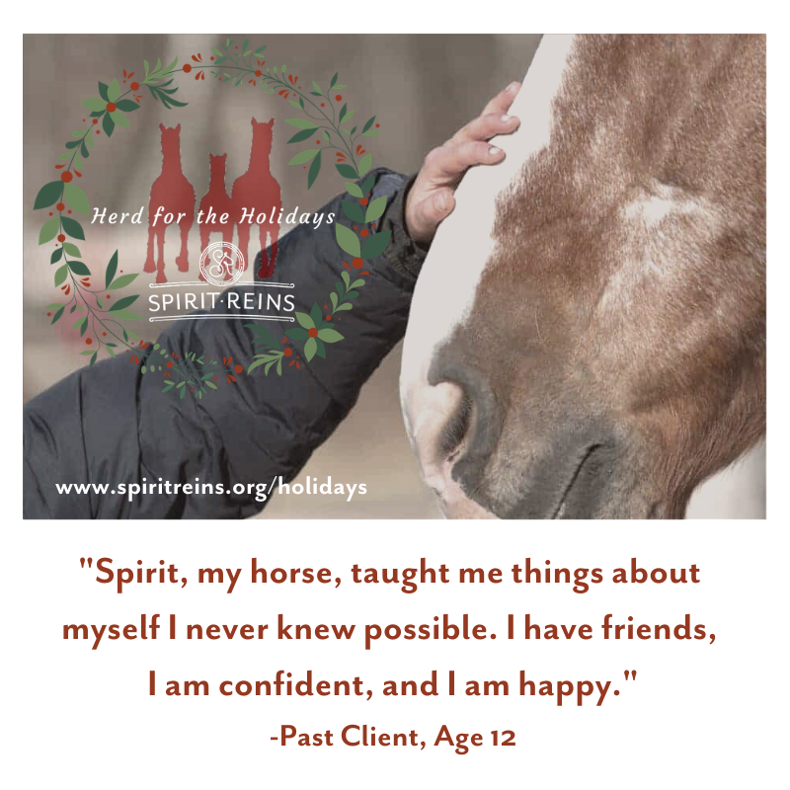

Post: December 22
[post copy]
I’m supporting Spirit Reins this holiday season because I know that when children and families heal from the past, they build hope for the future. If this mission resonates with you, I invite you to join me in being Herd for the Holidays!

https://www.spiritreins.org/holidays

[visual]
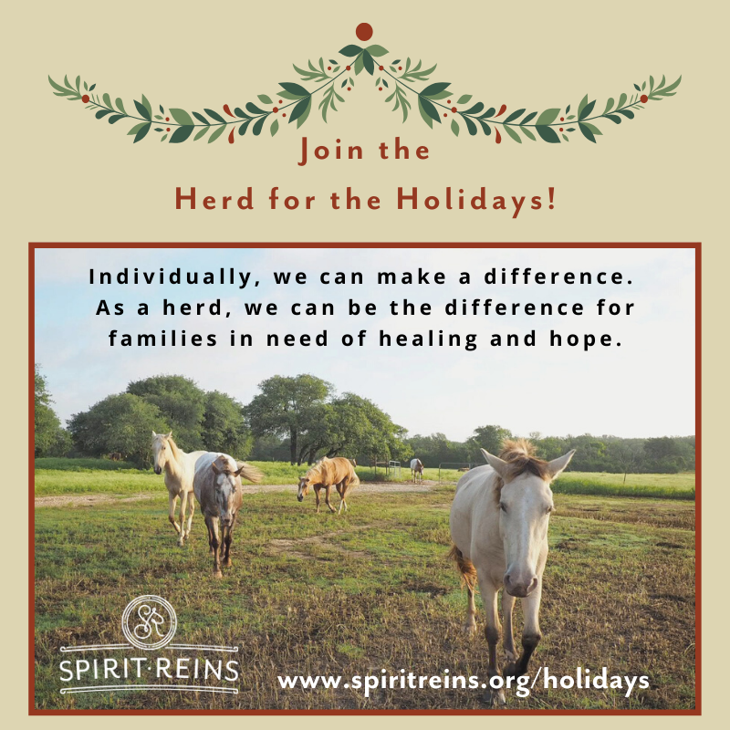

Post: December 30
[post copy]
Throughout this holiday season, I have felt incredible joy spending time with family and friends. I have been surrounded with love and laughter, and now I want to give these gifts to the children and families at Spirit Reins. I hope you will join me in making a gift and encouraging others to be Herd for the Holidays!

https://www.spiritreins.org/holidays

[visual]
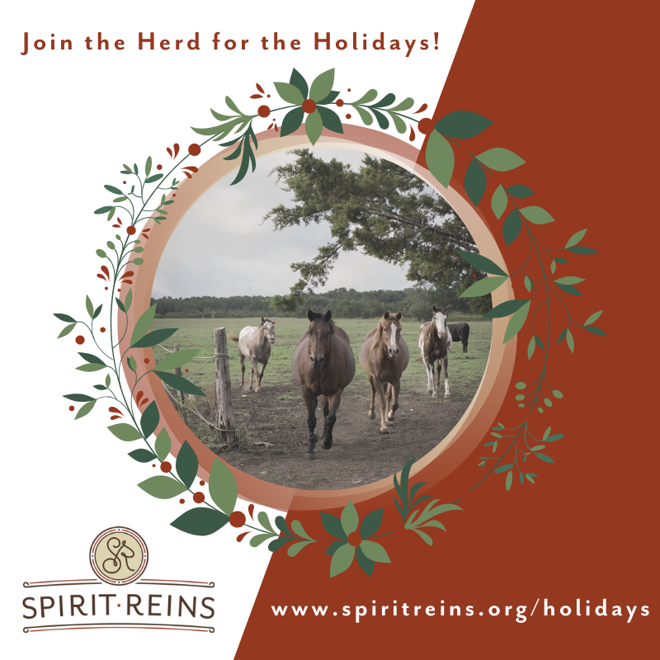 OR 